BALTIC AMBER MIGRATIONS AS A MODEL OF MICROPLASTICS BEHAVIOR IN THE SEA COASTAL ZONE

Irina Chubarenko, P.P.Shirshov Institute of Oceanology, Atlantic branch, irina_chubarenko@mail.ru
Margarita Bagaeva, P.P.Shirshov Institute of Oceanology, Atlantic branch,
guineus@ya.ru

Abstract. The problem of microplastic pollution is of increasing concern. Behaviour of microplastic particles (0.5 mm < L < 5mm in the largest dimension) in marine environment is difficult to predict, and no field observations are available up to now. Baltic amber (succinite), with its density of about 1.05-1.09 g/cm³, fits the range of densities of slightly negatively buoyant plastics: polyamide, polystyrene, acrylic, etc. Baltic citizens have observed amber migrations for centuries, and the collected information may shed some light onto general features of microplastic particles behaviour. Events of “amber washing-out” at the sea shore of the Sambian peninsula (Kaliningrad oblast, Russia) typically take place in autumn-winter time. Experience of divers indicates that amber is washed out from the depths as deep as 15 m. Massive presence in amber-containing debris of the red algae Furcellaria lumbricalis, dominating in the sea at depths of 6-15 m, proves this fact. From oceanographic viewpoint, important for the “amber washing-out” are: strong and long-lasting storm, phase of wind decrease or direction change, developed long surface waves, shore exposure to wind. Analysis of characteristic wave lengths after long storms, dimensions of their surf zone, and changes in underwater bottom profile is carried out. Conclusion is that slightly negatively buoyant microplastic particles should migrate for a long time between beaches and underwater slopes until they are broken into small enough pieces that can be transported by currents to deeper area and deposited out of reach of stormy waves.

Key words: microplastics, amber washing-out, coastal zone, stormy conditions

I. Introduction

The Baltic amber has its material density of about 1.05-1.09 g cm³, which is close to widely used plastics like polyamide (or nylon, 1.02−1.05 g cm³), polystyrene (1.04−1.1 g cm³), and acrylic (1.09−1.20 g cm³) [1]. Textiles, carpets and sportswear, flooring and rubber reinforcement, electrical equipment, films for food packaging and food containers, lids, bottles, trays, clothing, as well as furnishing fabrics, netting and traps, automotive applications, and many other products are made of them (e.g., [2]). Our awareness concerning problems related to plastic pollution of the Baltic Sea [3]), as well as severe lack of information on real migrations of plastics in the sea coastal zone, urges analyzing of any potentially informative cases in this regard. At the same time, Baltic citizens have known the phenomenon of “amber washing-out” and have monitored its behaviour in the coastal zone for ages. Thus, quite a rich set of natural facts is collected, which allows to shed some light onto the transport and fate of plastic particles as well.
The authors are not aware of any systematic investigation of physical conditions driving the amber migrations in the coastal zone, and have to rely on just descriptions of certain cases in books, newspapers, on web-sites, and on personal communications with amber hunters. (Amber hunting in the sea is considered by law like hobby-fishing or collecting berries or mushrooms in nature.)
The aim of this paper is to collect and analyse information on meteorological and hydrological conditions, surface wave field, locations and other important features corresponding to the cases when amber is washed ashore. Of especial interest are events of “amber washing-out”, when – after the most severe storms – large and heavy pieces of amber are transported to the beach from the depth of about 15-20 m; this phenomenon is termed as “brosy” by local citizens (the term is the derivative from the Russian word meaning "throwing out"). Further physical analysis is driven by the idea to predict some general features of behaviour of plastic litter and microplastic particles in the sea coastal zone.

II. Baltic amber properties and appearance on the beaches

Presence of amber on the swash-line of the Baltic Sea is quite a typical phenomenon for Kaliningrad beaches, and is very attractive for both local citizens and tourists. As a consequence, the conditions when it is observed are well known and very characteristic of this region: any more or less windy weather brings – here or there – an exclusive amber necklace along the beaches. Just windy episodes bring a lot, however, most of it are small amber pieces like crumbs of 1-2mm (Fig. 1), while heavier winds and especially severe winter storms may present amber samples up to 12 kg, like the piece found on the Baltic shore of Prussia in XIX century. Another two giant beached amber samples, reported in historical texts, had about 9700 and 7000 g. Such stones are washed out, however, extremely rare, and all the history knows less than 10 stones heavier than 5 kg [4]. The largest amber piece in the present-day collections is 47cm long and weighs 9.817 kg, it is exhibited in the Berlin Natural Science Museum [5]. Concerning the maximum total volume of the beached amber, local legends mention the event in 1862 when almost 2 tons of amber were beached during one storm [6]. Along with amber, a swash-line after storms contains seaweed, shells, wet wooden pieces, and nowadays they are very often mixed with some plastic garbage and microplastics particles.
Baltic amber is fossil resin produced by pine trees which grew in Northern Europe about 50 million years ago. In the course of time the resin was transformed to amber due to processes of polymerization and oxidation [7]. Until the XIII century seacoast inhabitants collected amber directly from the seashore, and later they learned how to obtain amber by combing the seabed with nets. With the appearance of the diving suit amber became also to be collected directly from the bottom of the sea.

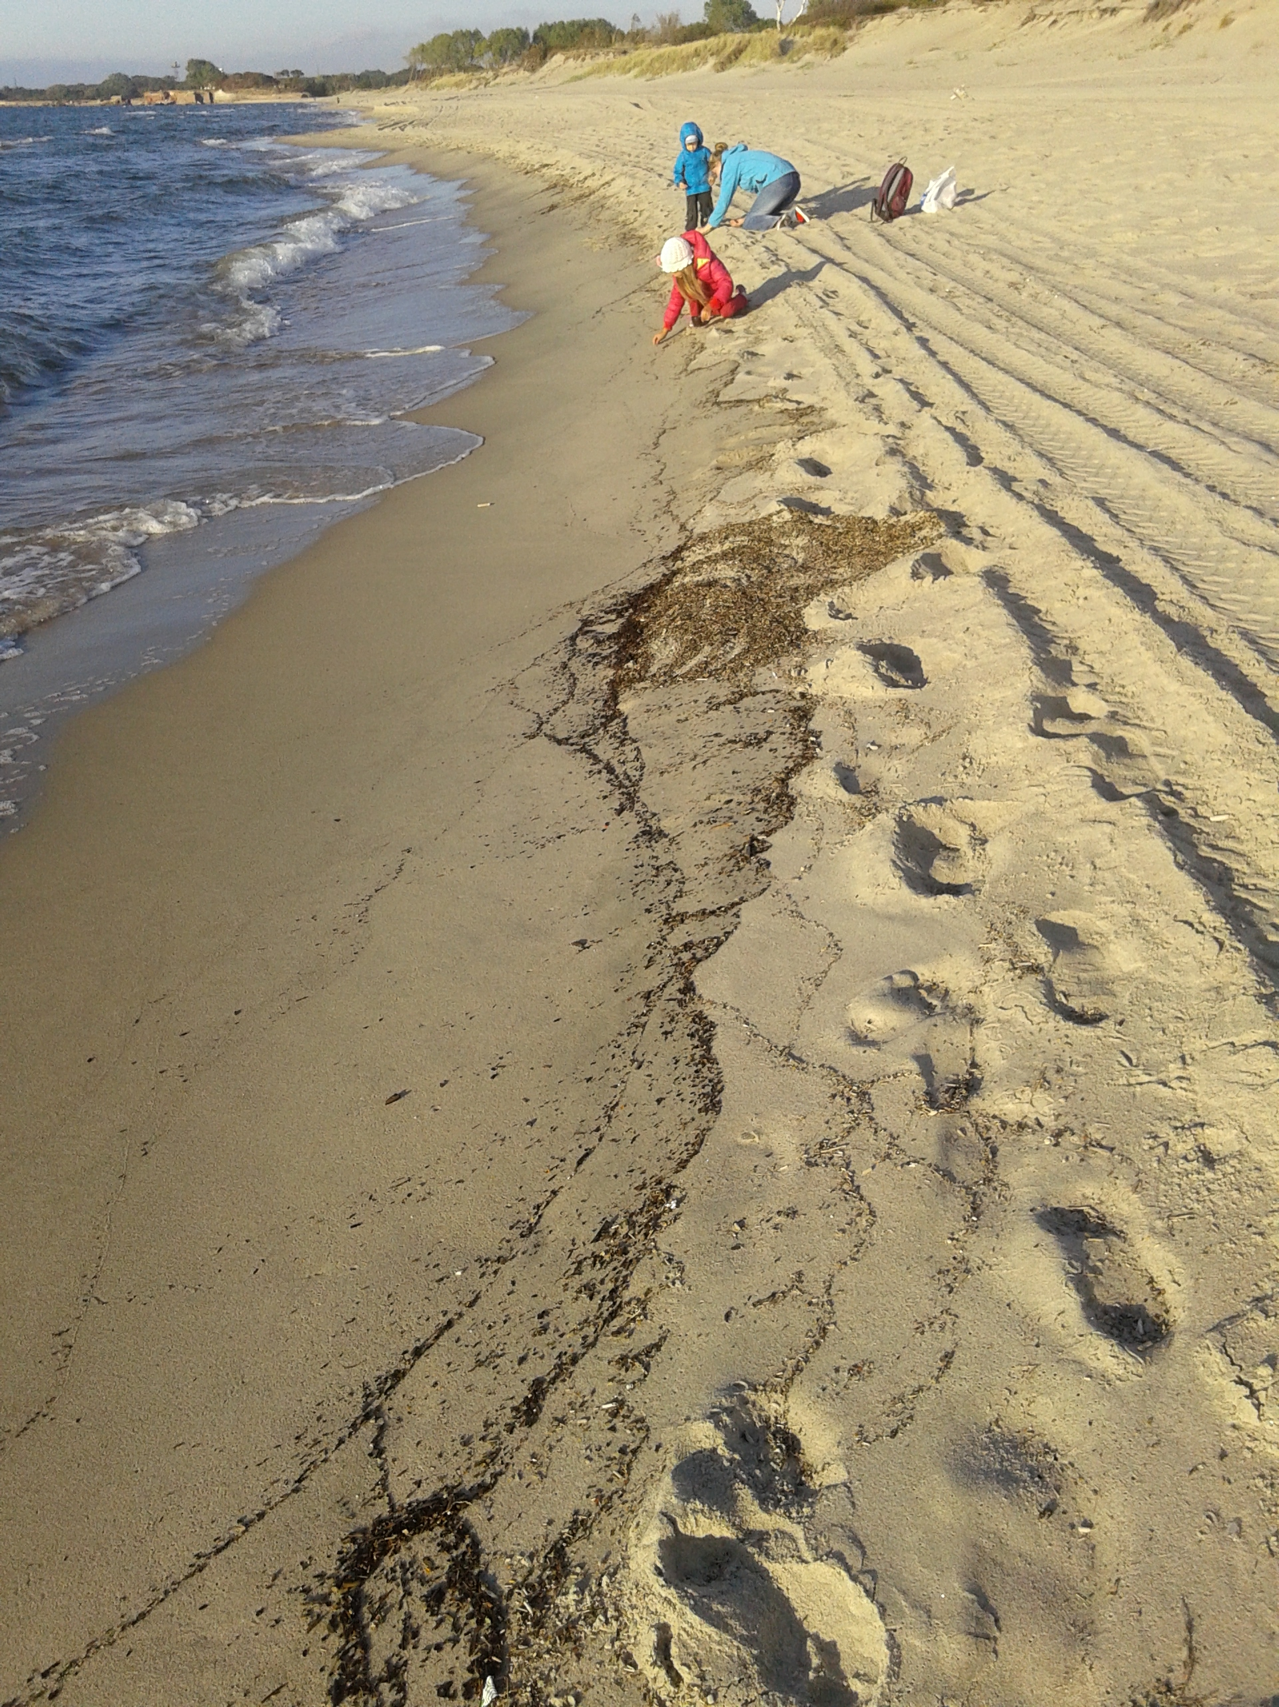 | 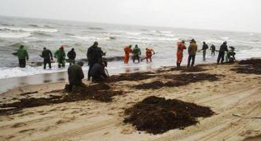
Fig. 1. The Baltic shore after moderate (left, photo by I. Chubarenko) and strong (right, photo from [8]) winds.
The very material of amber is naturally inhomogeneous, and the stones may also have various inclusions. This is why the specific gravity of amber varies from 1.05 to 2 g cm³ (very rarely). Anyhow, it cannot float in Baltic water (1.006 – 1.014 g cm³). Interestingly, specific gravity correlates with the colour: transparent amber is about 1.1 g cm³, while white amber may have the density as small as 0.93-0.96 g cm³ (as reported on [7], but not confirmed by specialists).
As it is illustrated by Fig. 1, amber pieces are able to move up-slope and appear at the shoreline even at moderate winds, however the major part of observational facts describe the cases after severe storms, when amber “brosy” are impressive indeed. These observations can be summarised as follows.
(I) The events of “brosy” of large amber pieces to the shore take place only several times per year and are most often during cold season of a year - spring, autumn and especially winter, however sometimes may happen also in summer (as it was quite recently – on 18 June 2014).
(II) Favourable are the situations when strong northern and western winds rise especially high waves.
(III) Duration of a storm is important: at least two-three stormy days are necessary.
(IV) The stage of wind weakening: amber is washed up from the bottom of the Baltic Sea only immediately after the storm, not during or a few days later. It happens several hours after the wind weakening, when winds are ceasing already – but the storm is still vivid, and when waves are still high, but the sea already begins to calm down. The cases have also been mentioned when winds change their direction, e.g., from the west to the south, south-east or east, but the waves are still approaching the coast from the west. If this moment is to missed – southerly or easterly winds will lead to water level drop, and the seaweed patches with amber will leave coastal zone together with water.
(V) There are favourable wind directions: western, south-western or northern winds.
(VI) The event of “brosy” takes place not along the entire shoreline, but only at certain separate (quite random) locations (Fig. 2), where wind is perpendicular to the shoreline. This way, most frequently it happens at some place along the concave 20-km long western fragment of the Kaliningrad shoreline from the Vistula Spit to Yantarny (see the map on Fig. 2): closer to the spit under northern or north-western winds, closer to Yantarny under western winds and winds with a south-western component. “Brosy” may happen along the northern Kaliningrad shore as well (from cape Taran to Zelenogradsk), when winds are from the north or north-west. The location of amber “brosy” is not permanent also within one stormy event – it changes together with the wind direction.
(VII) Patchiness: seaweed with amber comes to the shore in submerged patches, arising quite far from the shore right after the storm. Floating material is distributed within the patch throughout the entire water depth, from the bottom to the surface. The storm lifts the next portion of the seaweed with amber from the bottom, as a rule, in only a separate place. If, by some reason (usually – change of the wind direction), the patch begins drifting off-shore – it never comes back, and the “amber hunters” are then looking for another patch.

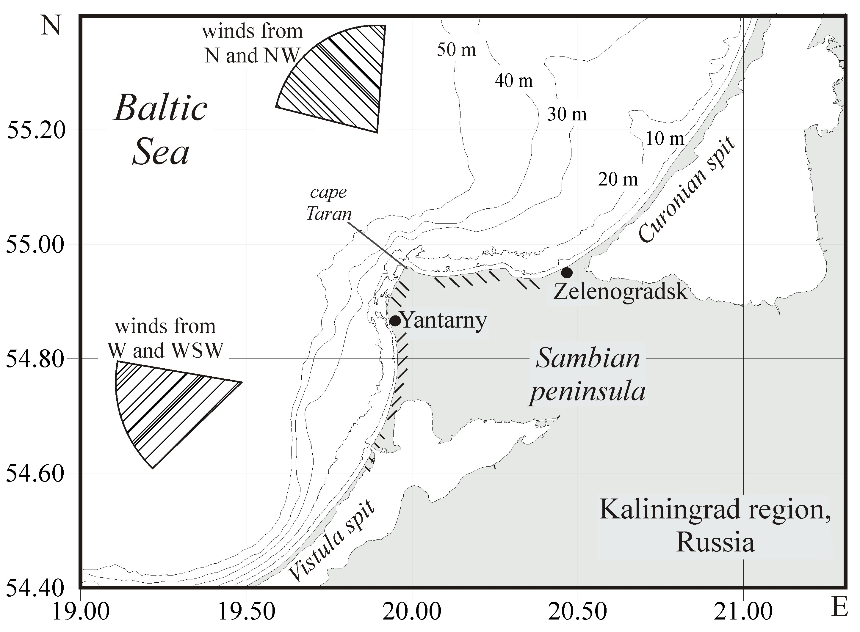
Fig. 2. Map of the region. Correlation of wind directions and locations of amber “brosy” is shown by similar hatching.

III. Where was the beached amber located on the underwater slopes?

The amber is usually found at depths from 3 to 12 m, maximum 15 m. One reason for this is that layers with amber-containing “blue clay” of the ancient Litorina Sea are located at the depths of 4-15 m below the sea level, stretching from Vistula Spit to Curonean Spit and further north [9]. However, amber is never washed ashore without plenty of seaweed, wooden sticks and marine litter. This suggests that the beached amber pieces are not directly washed out the sea bottom, but are just caught by seaweed clouds during their underwater migrations, exactly like other non-buoyant wooden or plastic pieces. An important observation is that amber is typically washed ashore together with red algae Furcellaria lumbricalis, which are abundant in the eastern part of the Baltic Proper and compose almost permanent belt along the shore [10], dominating on submerged rocks at the depths of 6-15 m [5]. Interestingly, it can also grow in large floating mats [5], and such mats are also mentioned quite often as washed ashore together with amber “brosy”. One way or another, it is quite obvious that amber pieces, which are heavier than water, are washed out during storms from the depths of about 6-10-15 m.

IV. Discussion: oceanographic viewpoint

The main physically important features of large amber “brosy” can be summarized as follows. In late autumn/winter/early spring, the thickness of the upper mixed layer is large – up to D~50-60 m in the Baltic Proper [11]. Thus, in the regions where the local depth d is smaller than D, vertical wind&convective mixing reaches the bottom, favouring the suspension of bottom material. After several days of storm, surface waves are already well developed, and their length and height can be estimated from their fetch. For the orientation of Kaliningrad shores, winds from the north, the north-west and the west have maximum wind fetch for this area (about 200-250 km [12]), and they rise the highest (H up to 7-8 m) and the longest (L up to 120-140 m) surface waves possible for this region (see the Baltic Sea wave diagram, Fig. 7.11 of [12]).
It is generally assumed that the border between deep and shallow surface waves is associated with the depth d ~ 0.5 L (i.e., again about 60 m in the considered case), so that over shallower regions the surface waves “feel” the bottom and, hence, bottom sediments “feel” water motion due to surface waves [12]. The surf zone of the highest waves begins at the depth d ~ 2 H (about 15 m), while other stormy waves are breaking over depths from 2 H to 1-1.5 H (from 15 to 7 m) [12]. This very depth range is pointed out as the source where amber-containing patches arise, and the distance from the shore to the isobaths 15 m and 7 m is only 3-5 km. With quite moderate (for stormy conditions) water currents of the scale of 0.3-0.5 m/s, it should take about 5 km/0.5 m/s=10⁴ s ~ 3 h only for the patch to reach the shore.
The observations summarized above (I)-(VII) indicate that both strong wind and developed surface waves are important, however, the very mechanism lifting the patch from the bottom to the surface has not yet been disclosed. We suggest that this can be the Langmuir circulation (LC): the coherent system of large longitudinal rolls, with their axes directed downwind, arising due to instability of wind-induced current in presence of Stokes wave drift. In addition to wind+wave nature of the LC [13], at least two other characteristics of the “brosy” underpin this idea.
First, the most essential feature – the patchiness (in longshore direction) - can be explained by separation of upwelling zones in-between Langmuir rolls. Assuming that the largest Langmuir cells embrace the depth of about 60 m (the thickness of the upper mixed layer) and taking depth-to-width ratio of an individual cell as about D/W~1.3÷3 [14], one can estimate the smallest spacing between upwelling zones as 80-180 m. Since these zones, resulting from instability of wind-induced current in presence of surface wave transport, are inherently different in intensity, the patchiness of the seaweed clouds lifted from the bottom is natural. The resuspension should take place at some distance from the shore – where the cells are not yet modified by the shoaling, which again agrees with field evidence.
The second observation supporting the LC-idea is that the “brosy” arise when the wind speed is already decreasing. It is known [13] that the LC arises at wind speeds of more than 5 m/s and persists at higher and higher winds until stormy mixing destroys its coherent structure (at more than ca. 25 m/s). With the “brosy”, we may have an opposite case: stormy wind ceases – and LC becomes evident. Note that horizontal water transport within the upwelling zones is directed down-wind, so that the patch in the considered case is to be beached at the shore directly exposed to it. This is in full agreement with observations as well.
Is the LC able to lift amber stones or microplastic particles from the bottom? The settling velocity of microplastics (0.5-5 mm long) particles with the amber density of 1.05 g/cm³ varies between 1 and 5 cm/s [1], while the maximum vertical velocity in LC under (quite moderate) wind speeds of 2–12 m/s ranges from 2 to10 cm/s [15]. Thus, the LC is physically able to suspend the seaweed cloud from the bottom and transport it to the shore line.

IV. Conclusions: application to microplastics

Considering the behaviour of amber pieces as a physically equivalent example for microplastic particles, we may conclude that the latter have a long and complicated path from our beaches to the deep sea. Thrown on the beach, non-buoyant macro-plastics are soon captured by developing stormy waves and transported towards the deep sea; but later, when the storm ceases, they are able to come back to the swash zone and the shore line – to be mechanically destroyed and UV-degraded, and washed to the sea again and again – until micro-plastic pieces will be small and light enough to leave the coastal zone with stormy water currents.
The main critical factors for microplastics migrations in sea coastal zone are, thus, wind properties, features of surface wave field, and Langmuir circulations. In particular, these phenomena are very difficult to reproduce in numerical models. So, thinking about further numerical modeling of microplastics generation and migration processes, as well as its transport in the Baltic Sea, we suggest that possible solution may be shifting off-shore (to the iso-bath of about 20-25 m) the boundary, which exports the microplastics particles towards the deep sea.
An ecological point is also worth noting here. The red algae F. lumbricalis, which seems to be involved in / touched anyhow by the microplastic migration process, is also an important habitat-forming seaweed: its underwater "belts" provide spawning habitat for many fish species, and for this reason some governments even place regulations on the harvesting of this seaweed. This danger of presence of microplastics in marine environment has not been disclosed before the presented analysis.

V. Acknowledgment

Investigation of physical and dynamical features of marine microplastics particles is supported by Russian Science Foundation via grant number 15-17-10020.

VI. References

[1] I. Chubarenko, A. Bagaev, M. Zobkov, E. Esiukova, “On some physical and dynamical properties of microplastic particles in marine environment,” Marine Pollution Bulletin, 2016 (in press) DOI: 10.1016/j.marpolbul.2016.04.
[2] V. Hidalgo-Ruz, L. Gutow, R.C. Thompson, and M. Thiel, “Microplastics in the marine environment: A review of the methods used for identification and quantification,” Environ. Sci. and Technol., vol. 46, pp. 3060–3075, 2012.
[3] EU Commission, “Guidance on monitoring of marine litter in European seas,” EU Commission, Joint Research Centre, MSFD Technical Subgroup on Marine Litter, 2013.
[4] http://amberhunters.com/
[5] https://www.wikipedia.org/
[6] http://www.mk.ru/
[7] http://www.amberseaside.com/
[8] http://www.kaliningrad.kp.ru/
[9] O.V. Petrov (Ed), Atlas of geological and environmental geological maps of the Russian area of the Baltic Sea. SPb., VSEGEI, 2010. 78 p. ISBN 978-5-93761-165-9
[10] M.S. Kireeva, “Distribution and biomass of seaweed of the Baltic Sea,” Proceedings of VNIRO, vol. 42, pp. 195-205, 1960.
- [11] M. Leppäranta, K. Myrberg, Physical Oceanography of the Baltic Sea. Springer, Praxis Publishing. Chichester, UK. 370 pp. 2008.

[12] R. Feistel, G. Naush, N.J. Wastmund (Eds), State and Evolution of the Baltic Sea, 1952-2005. A Detailed 50-Year Survey of Meteorology and Climate, Physics, Chemistry, Biology, and Marine Environment. Wiley & Sons. 712 pp. 2008.
[13] A.D.D.
Craik, S. Leibovich, “A rational model for Langmuir circulations,” Journal of Fluid Mechanics, vol. 73, pp. 401-426, 1976.
[14] I. Chubarenko, B. Chubarenko, E. Esiukova, H. Baudler, “Mixing by Langmuir circulation in shallow lagoons,” Baltica, vol. 23 (1), pp. 13-24, 2010.
[15] S.
Leibovich, “The form and dynamics of Langmuir circulations,” Ann. Rev. Fluid Mech., vol. 15, pp. 391-427, 1983.

